Alexander the Great: Map Questions
Directions: Use Maps 1 and 2 To Help You Answer the Questions on the Right
1. (Map 1) Where did Alexander begin conquering?
2. (Map 1) How many miles did his Empire stretch (East to West)?
3. (Map 1) List the sites of the major battles
4. (Map 2) List 5 modern day nations that Alexander’s Empire covered (LARGE Bold Print).

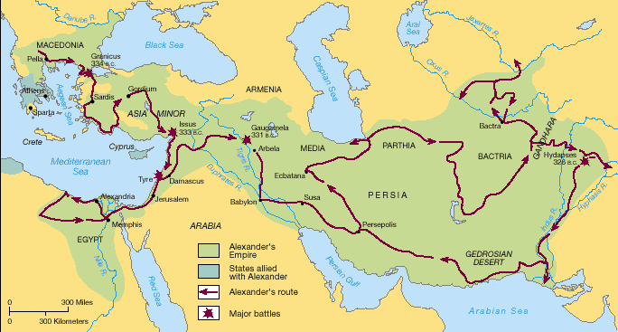
M
A
P
#
1
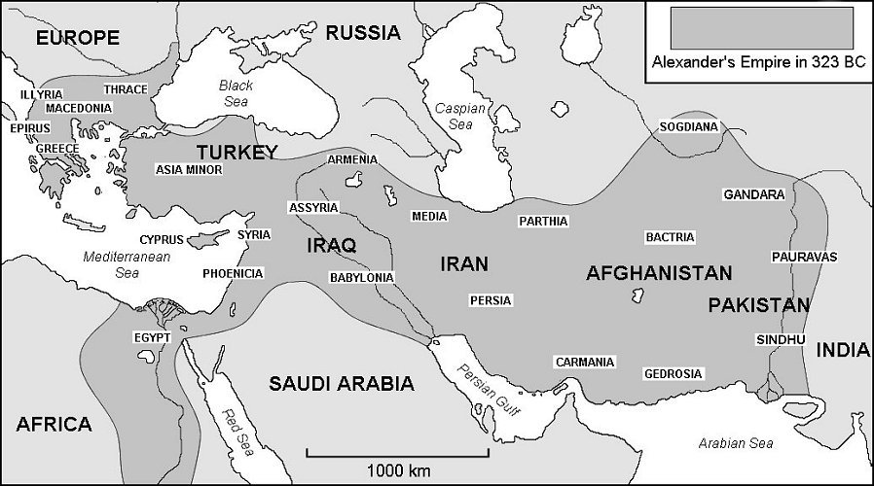

MAP # 2
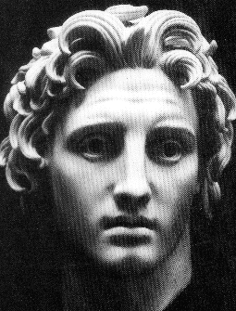
Alexander The Great
Alexander was a prince, the son of the king of Macedonia. He was born in Macedonia in July 356 BCE. Macedonia was not a Greek city-state. It was a country in the north of Greece.
Alexander was taught for four years by his teacher, Aristotle. Aristotle instructed Alexander in politics, war, and in critical thinking. At the age of 16, Alexander was made a captain in the Macedonian armies where he gained the respect of his soldiers for his bravery, and battle strategies. When Alexander was 20 years old, his father was murdered - Alexander became the king of Macedonia.
He quickly dealt with his enemies at home and reasserted Macedonian power within Greece. He then set out to conquer the massive Persian Empire.
Against overwhelming odds, he led his army to victories across the Persian territories of Asia Minor, Syria and Egypt without suffering a single defeat. The young king of Macedonia, leader of the Greeks, overlord of Asia Minor and pharaoh of Egypt became 'great king' of Persia at the age of 25.
Over the next eight years, Alexander led his army 11,000 miles, founding over 70 cities and creating an empire that stretched across three continents from Macedonia to the Indus River, covering around two million square miles. Alexander had conquered the ENTIRE known world in the Mediterranean region.
At the age of 33, Alexander contracted a fever, which quickly took his life. The empire he had worked so hard to build was divided among three of his generals, whose decedents ruled these three territories as separate empires.
Alexander Spreads Hellenistic Culture
Even though his kingdom did not last long, his influence did. The conquests of Alexander spread the Greek culture throughout much of Europe and Asia.
The Greek culture of Alexander mixed with other cultures of the areas he conquered, forming a new type of culture which is today referred to as Hellenistic Culture. Elements of Hellenistic Culture can even be found today in the areas conquered by Alexander’s Empire.
Information from:
http://www.kidspast.com/world-history/0074-alexander-the-great.php
http://greece.mrdonn.org/alexander.html
http://www.bbc.co.uk/history/historic_figures/alexander_the_great.shtml
Questions
1. Why did Alexander become King so young?

2. Who taught Alexander at a young age? What did he teach him about?

3. What major civilizations did Alexander conquer?

4. How did Alexander die? What happened to his Empire after his death?

5. What type of culture did Alexander spread (besides Greek)?

